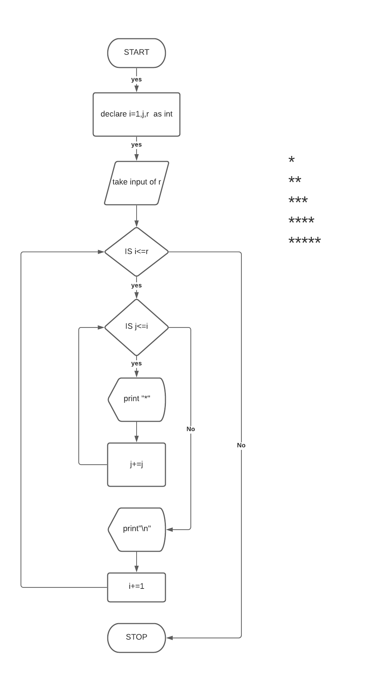

Algorithm:

Step1: Start

Step2: declare variable r,i=1 and j as integer

Step3: take input of r

Step4: Repeat Step 5 to 10 if i<= r

Step5: initialize j=1

Srep6: Repeat Step 7 -8 if j<=i

Step7: print \*

Step8: j+=1

Step9: print “\n”(new line)

Step10: i+=1

Step11: Stop

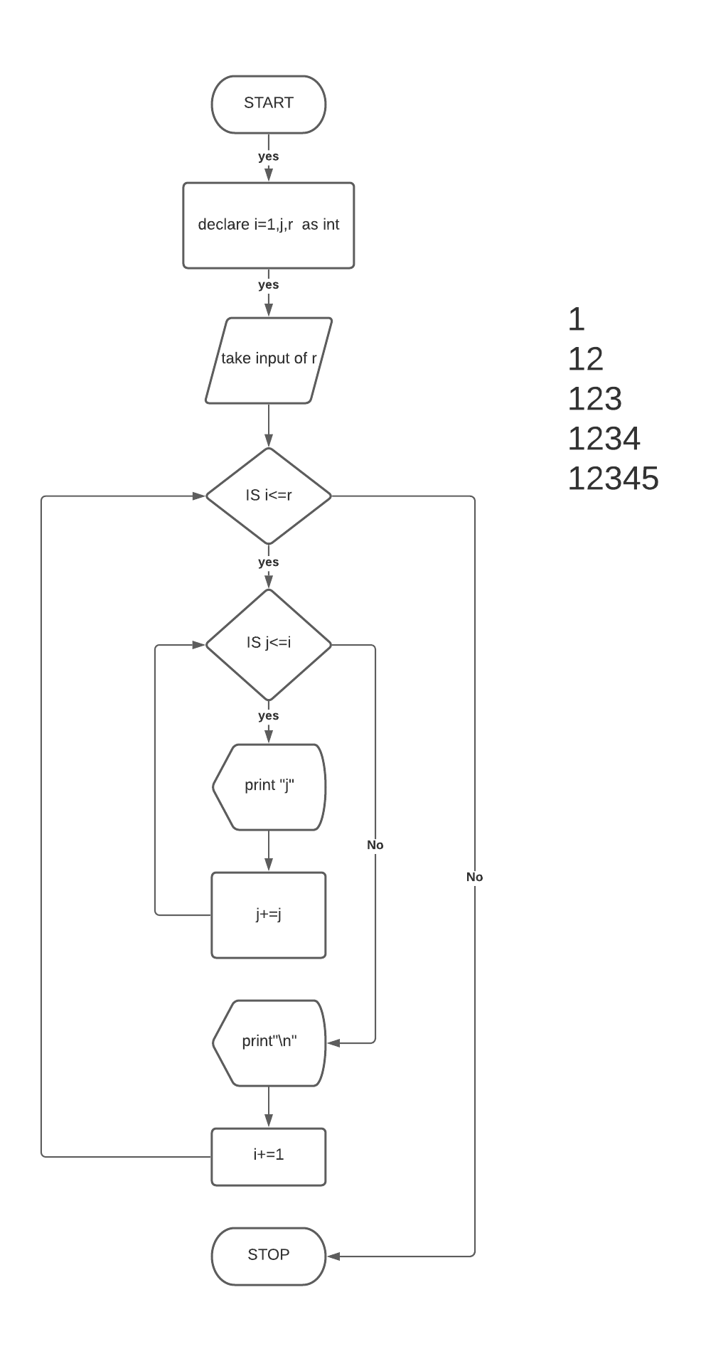

Algorithm:

Step1: Start

Step2: declare variable r,i=1 and j as integer

Step3: take input of r

Step4: Repeat Step 5 to 10 if i<= r

Step5: initialize j=1

Srep6: Repeat Step 7 -8 if j<=i

Step7: print j

Step8: j+=1

Step9: print “\n”(new line)

Step10: i+=1

Step11: Stop

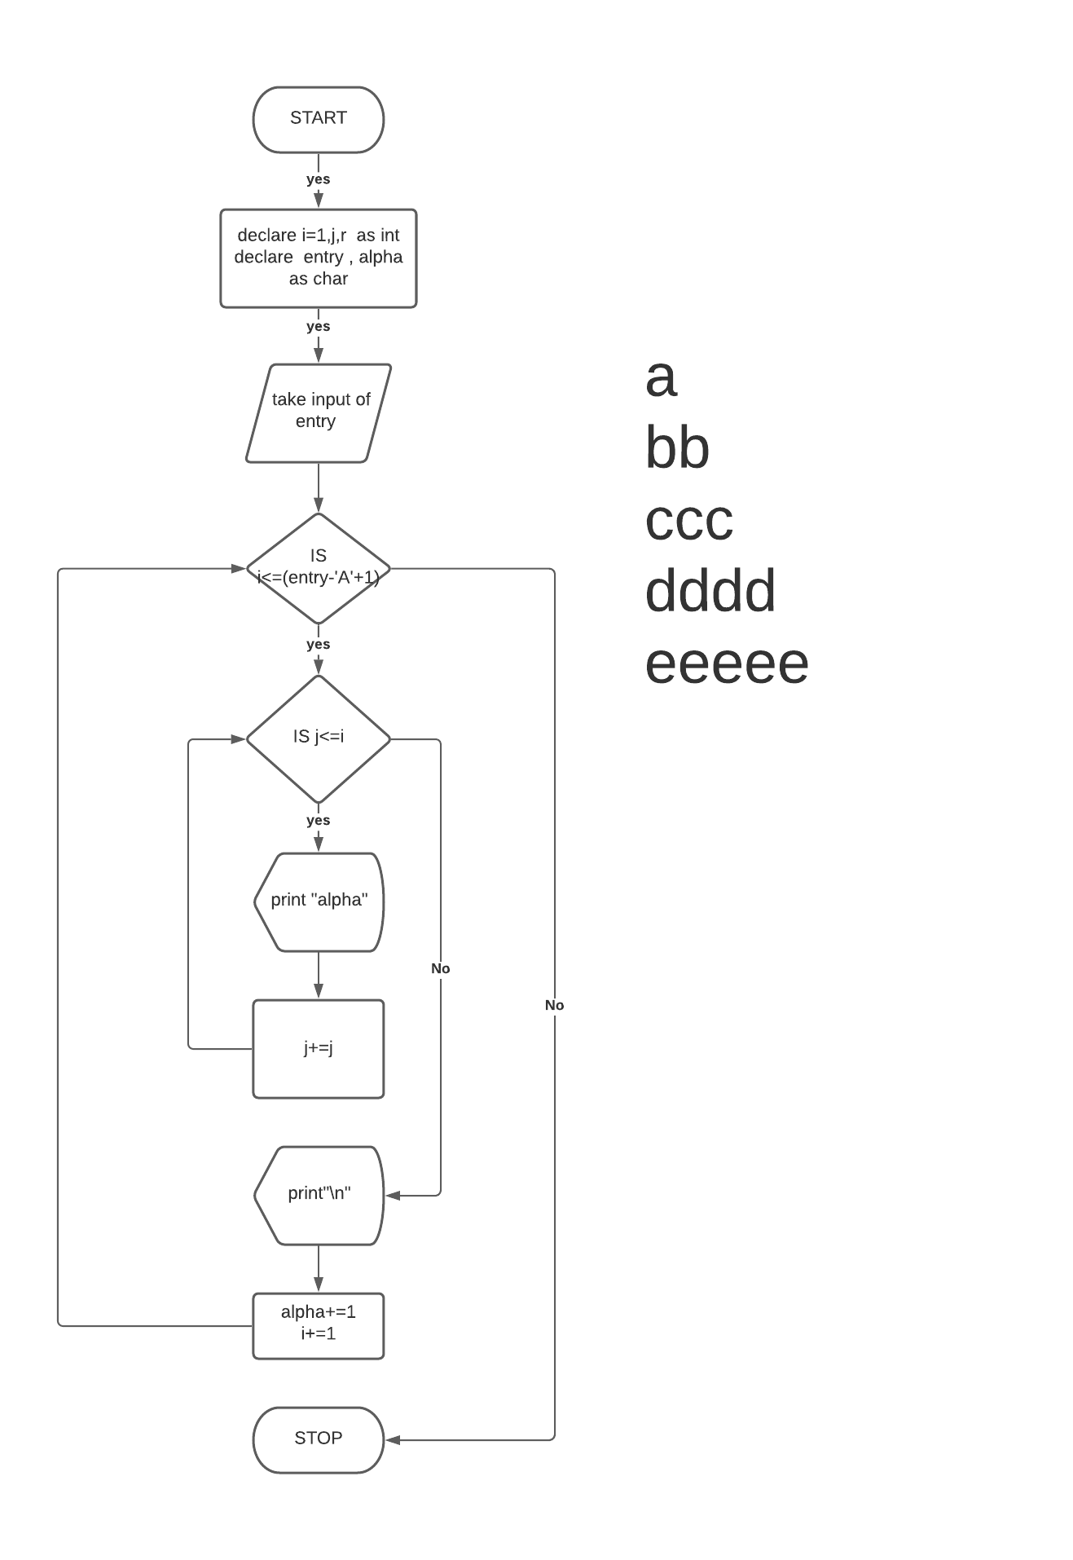

Algorithm:

Step1: Start

Step2: declare variable i=1,j as integer And alpha=’A’, limit as Character

Step3: take input of limit

Step4: Repeat Step 5 to 11 if i<= (limit-‘A’+1)

Step5: initialize j=1

Srep6: Repeat Step 7 -8 if j<=i

Step7: print alpha

Step8: j+=1

Step9: print “\n”(new line)

Step10: i+=1

Step11: alpha+=1

Step12: Stop

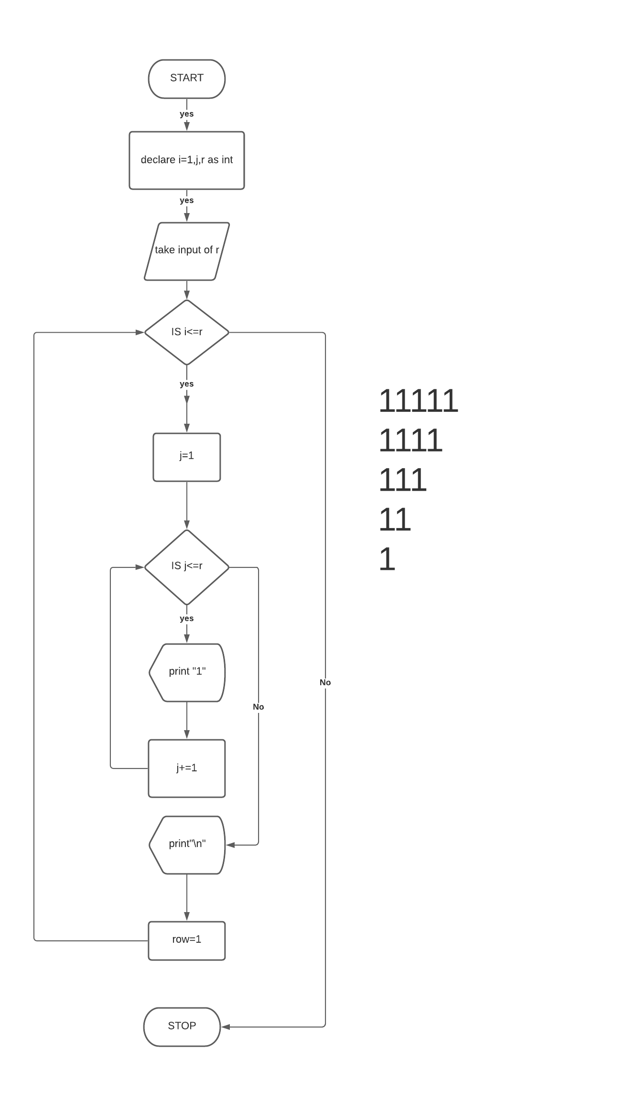

Step1: Start

Step2: declare variable r ,j,i=1 as integer

Step3: take input of r

Step4: Repeat Step 5 to 10 if r>=1

Step5: initialize j=1

Srep6: Repeat Step 7 -8 if j<=r

Step7: print “1”

Step8: j+=1

Step9: print “\n”(new line)

Step10: i-=1

Step11: Stop

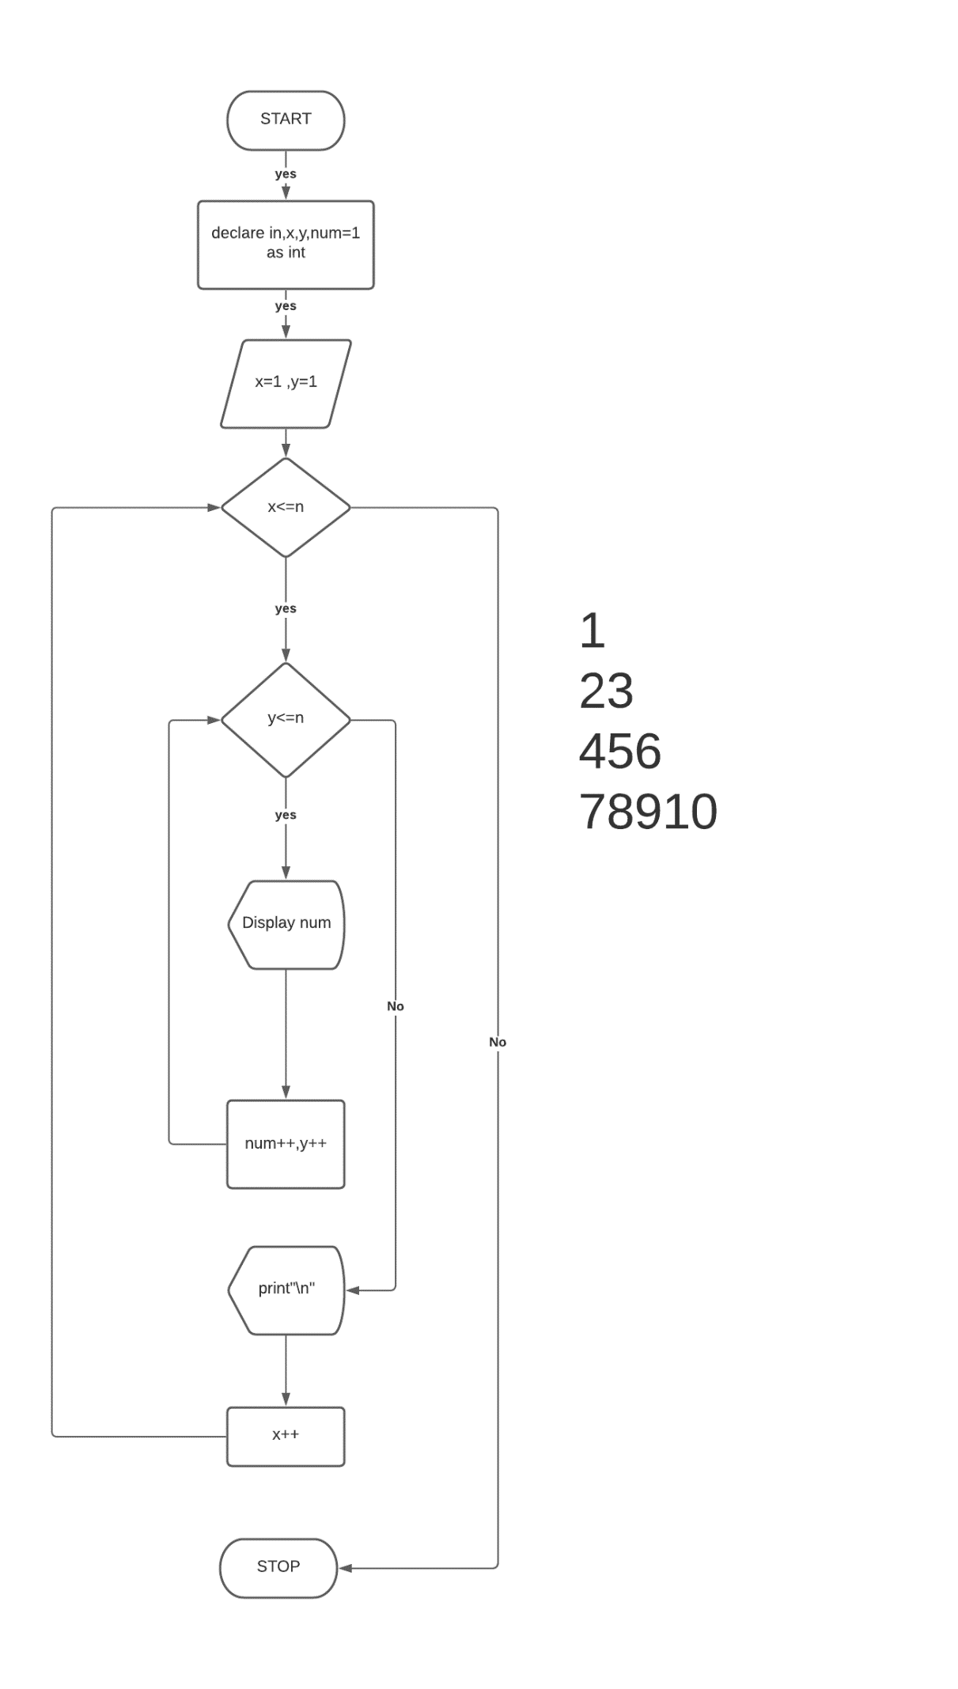

Algorithm:

Step1: Start

Step2: declare variable x,y,num=1 and row as integer

Step3: take input of row

Step4: Repeat Step 5 to 10 if i<= row

Step5: initialize y=1

Srep6: Repeat Step 7 -to 9 if y<=x

Step7: print num

Step8: num+=1

Step9: y+=1

Step10: print “\n”(new line)

Step11: x+=1

Step12: Stop

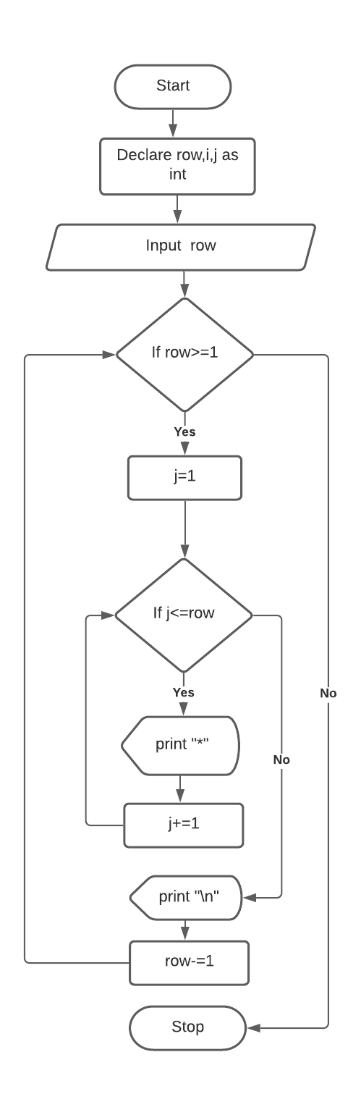

\*\*\*\*\*

\*\*\*\*

\*\*\*

\*\*

\*

Algorithm:

Step1: Start

Step2: declare variable row and j as integer

Step3: take input of row

Step4: Repeat Step 5 to 10 if row>=1

Step5: initialize j=1

Srep6: Repeat Step 7 -8 if j<=row

Step7: print “\*”

Step8: j+=1

Step9: print “\n”(new line)

Step10: i-=1

Step11: Stop